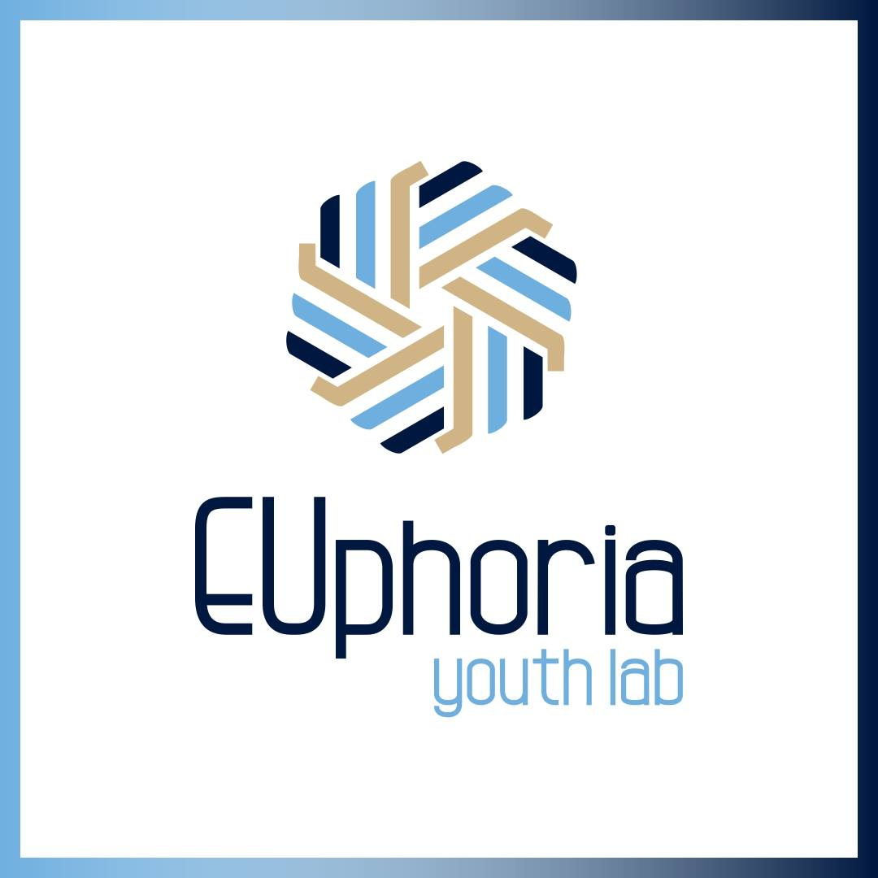
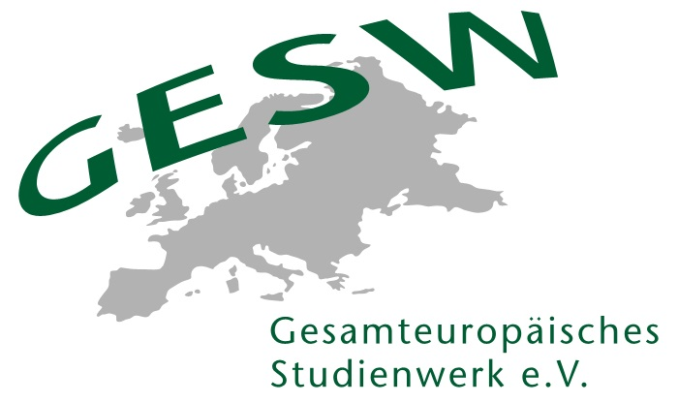

Gr.A.C.E.- International Programs
Unlocking Memories
Application/Registration Form
German-Greek-Italian Youth Exchange

Team Leader, Germany: Navina Engelage
Ypati, Athens (Greece): 07.-14.10.2019
Vlotho (Germany): 14.03.-21.03.2020
The exchange is co-funded by the European Union (Erasmus+ Programme) and by the German Federal Youth Ministry (KJP). The participation fee is 60€ (included are accommodation, meals, program)
Travel Costs will be partially refunded. Travel to an activity within the home country will be subsidized depending upon the distance to the location of the activity. Travel to an activity abroad will be subsidized up to 275€.
Please note: The bus transfer from Athens to Ypati and from Ypati to Athens costs approx. 30-40€ (total price for return trip). The costs are not included in the participation fee.
Participants must be between 18 and 26 years and ready to participate fully in both activities.
They must be able to speak English so well that they can follow the seminar contents.
Please complete the form by 26th August 2019 and send it to Navina Engelage: navina.engelage@gesw.de
---
I hereby wish to apply for the exchange experience Unlocking Memories – Remembering the Past, Shaping the Future for young people from Germany, Greece and Italy.

Personal Data

Last name

First name

Prefix (Mr./Mrs.)

Home address incl. country

Nationality

Date of birth (DD/MM/YY)

Email address

Mobile number

Institutional/Academic Background

University (if applicable)

Field of study / Study program (if applicable)

Institution or current employment (if applicable)

Major themes of study / Topics of interests

Dietary Needs

Vegetarian (Yes/No)

Dietary needs (intolerances etc.)
Health

Health condition (allergies etc.)

Emergency contact (Name, mobile number)

Could you please specify below, why you want to participate in this program?

Further Proceedings
Upon viewing the applications, you will hear from us by 30th August.

Data Protection
We protect the personal data of participants. All participants' data will be considered confidential and will be handled in accordance with data protection guidelines. Personal data includes all data that is stored in connection with the names of participants. Information shared by participants is stored in our customer database and is used for the purposes of providing services; this information will not be disclosed to third parties.

We will occasionally send participants information about our upcoming events; participants can choose to unsubscribe from these emails at any time. If networking is one of the goals of the event for which the participant has registered, the participant’s name, institution, and email will be published in a list of participants and distributed to other participants and speakers at the same event. Participants can choose to opt out from sharing their information; however, for organizational reasons we ask that such requests be submitted in writing to navina.engelage@gesw.de well in advance of the start of the event.

Dietary Needs
Our institution will gladly accommodate to any dietary needs that you may have. However, we inform you that while we will refrain from serving pork to groups with Muslim participants, we cannot guarantee the serving of halal meat. If this is inacceptable to you, we will offer you vegetarian options.

