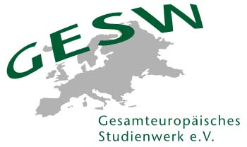
International Programs
Living and shaping Democracy
Application/Registration Form
German-Tunisian Exchange Program 2019

Team Leader: Navina Engelage

Vlotho/Berlin: 02.09.-10.09.2019
Hammam Sousse: 16.11.-23.11.2019
The program is supported by the German Federal Foreign Office. The participation fee is 365 €.
Participants can receive a partial refund of travel costs (max. 383 €).
Participants must be between 20 and 28 years and ready to participate fully in both activities.
They must be able to speak English so well that they can follow the seminar contents.
Please complete the form by 10th July 2019 and send it to Navina Engelage: navina.engelage@gesw.de
---
I hereby wish to apply for the exchange and empowerment experience LIVING AND SHAPING DEMOCRACY for young people from Germany and Tunisia.

Personal Data

Last name

First name

Prefix (Mr./Mrs.)

Home address incl. country

Nationality

Date of birth (DD/MM/YY)

Email address

Mobile number

Institutional/Academic Background

University (if applicable)

Field of study / Study program (if applicable)

Institution or current employment (if applicable)

Major themes of study / Topics of interests
Dietary Needs

Vegetarian (Yes/No)

Dietary needs (intolerances etc.)

Could you please specify below, why you want to participate in this program?

Further Proceedings
Upon viewing the applications, you will hear from us by 17th July.

Data Protection
We protect the personal data of participants. All participants' data will be considered confidential and will be handled in accordance with data protection guidelines. Personal data includes all data that is stored in connection with the names of participants. Information shared by participants is stored in our customer database and is used for the purposes of providing services; this information will not be disclosed to third parties.

We will occasionally send participants information about our upcoming events; participants can choose to unsubscribe from these emails at any time. If networking is one of the goals of the event for which the participant has registered, the participant’s name, institution, and email will be published in a list of participants and distributed to other participants and speakers at the same event. Participants can choose to opt out from sharing their information; however, for organizational reasons we ask that such requests be submitted in writing to navina.engelage@gesw.de well in advance of the start of the event.

Dietary Needs
Our institution will gladly accommodate to any dietary needs that you may have. However, we inform you that while we will refrain from serving pork to groups with Muslim participants, we cannot guarantee the serving of halal meat. If this is inacceptable to you, we will offer you vegetarian options.

